NAME: ALPANA SINGH

PROJECT NAME: ARTVILLE

THEME: WEB DEV

Role:

I made the Home page, the art corner page, the login page, the signup page in the Artville Webpage

What I learned while building the project:

HTML, CSS

Course names (I referred to while working for the project):

Udemy course: <https://www.udemy.com/share/101v3gAEATcFxWQHgJ/>

Youtube:

<https://youtu.be/mU6anWqZJcc>

<https://youtu.be/yQimoqo0-7g>

Libraries used in the project:

No libraries used

Work flow of the project:

I first created the home page with the responsive navbar, the about us section, two responsive buttons ie. The signup and Sign in buttons that will redirect to the signup page and login page respectively.

Then I have created the login page, sign up page and the art page where we have displayed some artworks.

Screen shots:

GITHUB ACCOUNT LINK: <https://github.com/Alpana0905/ARTVILLE>

HOME PAGE:

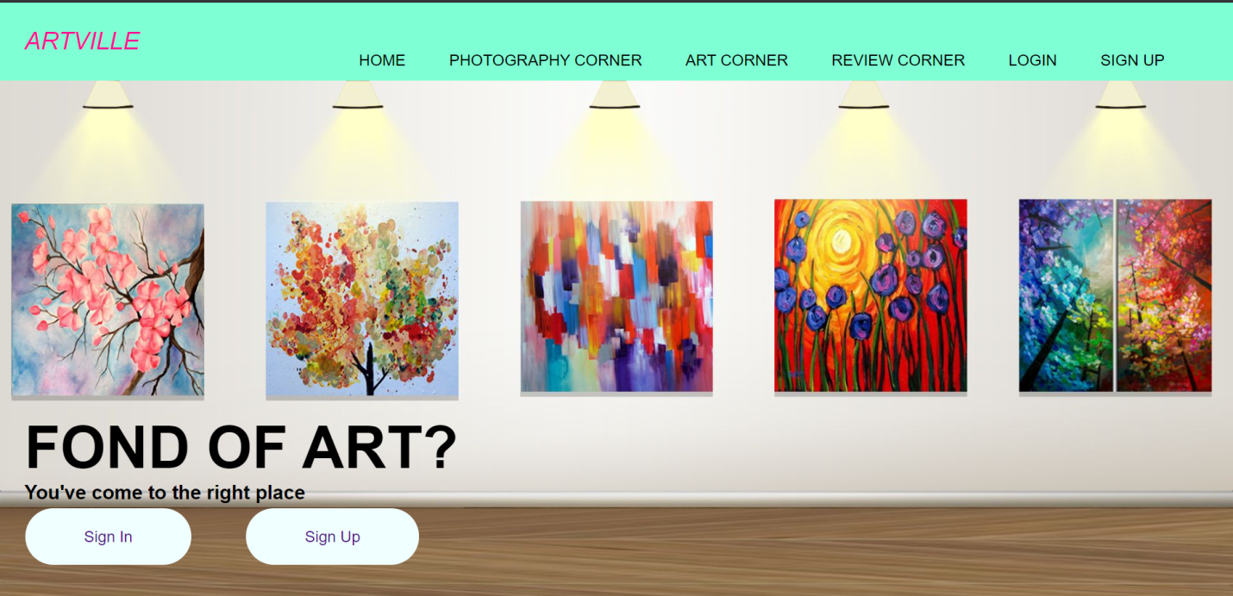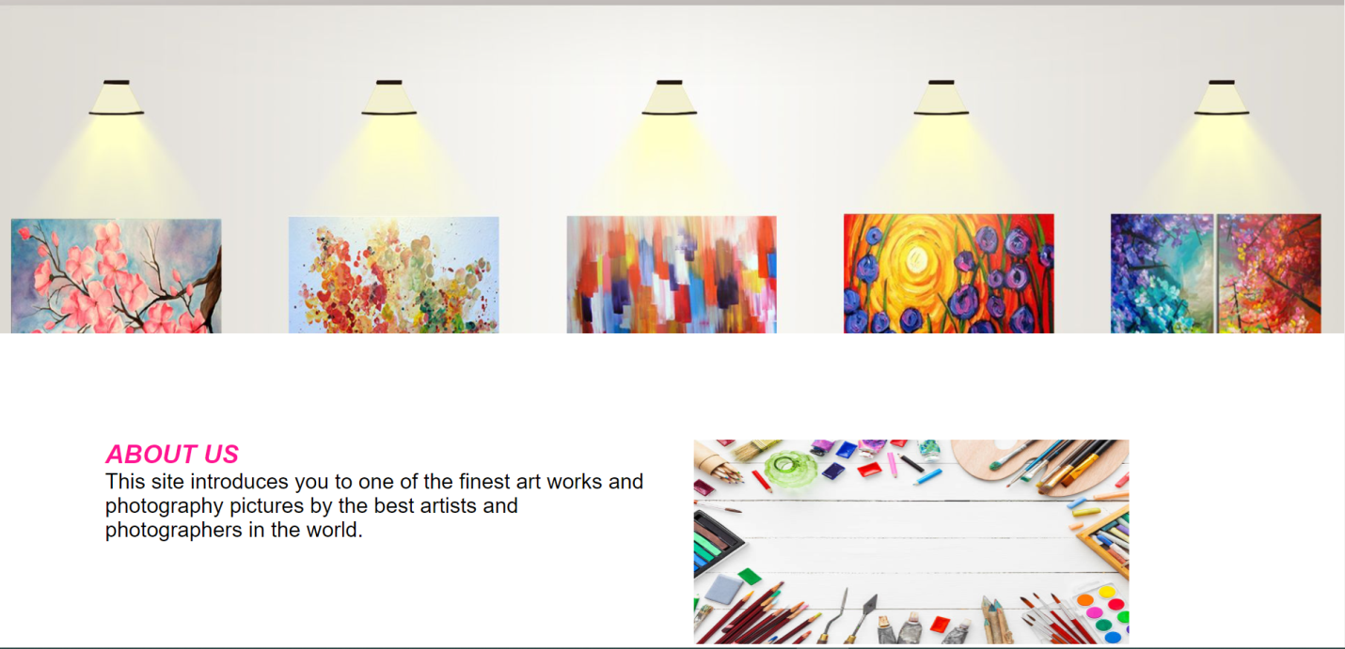

ART CORNER PAGE:

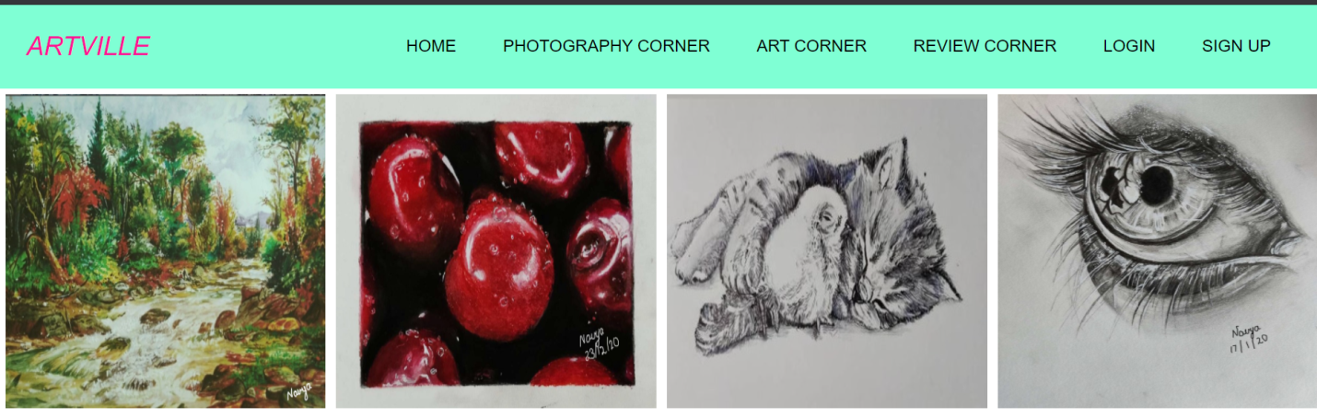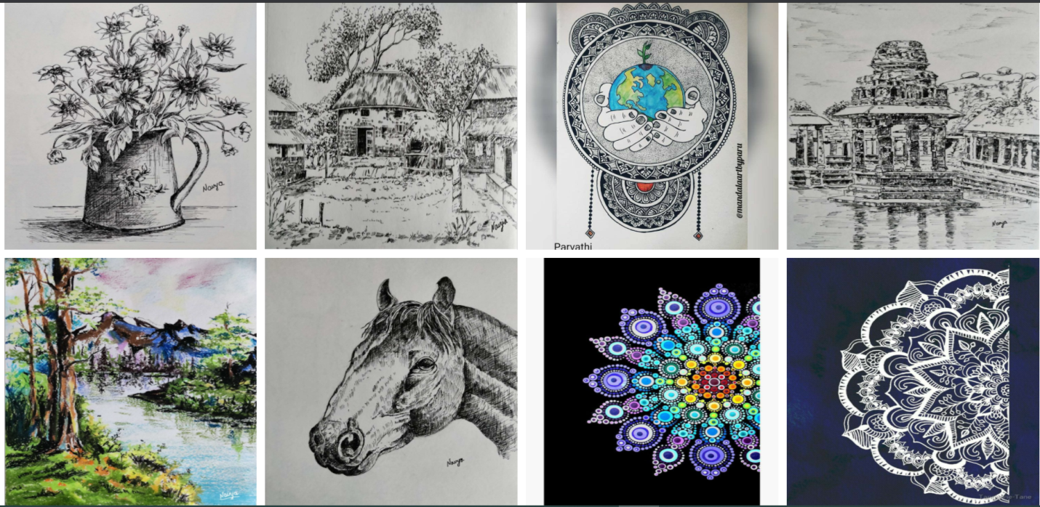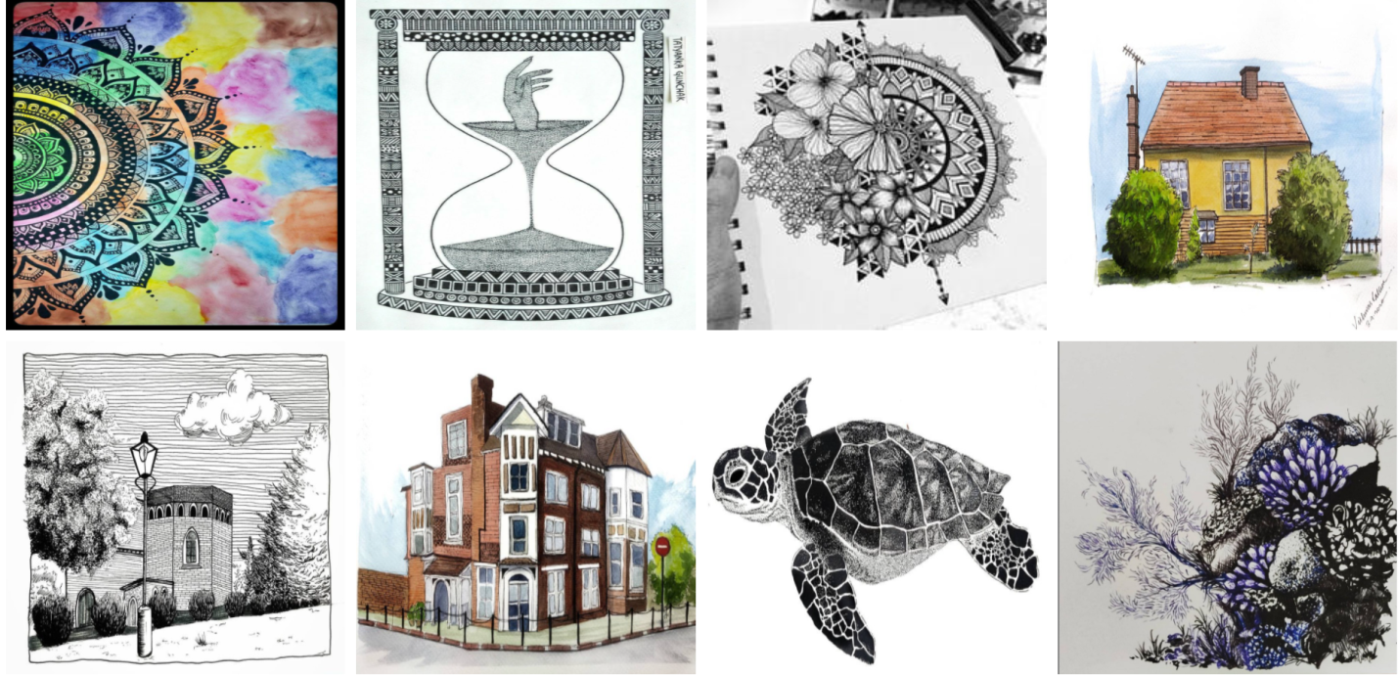

LOGIN PAGE:

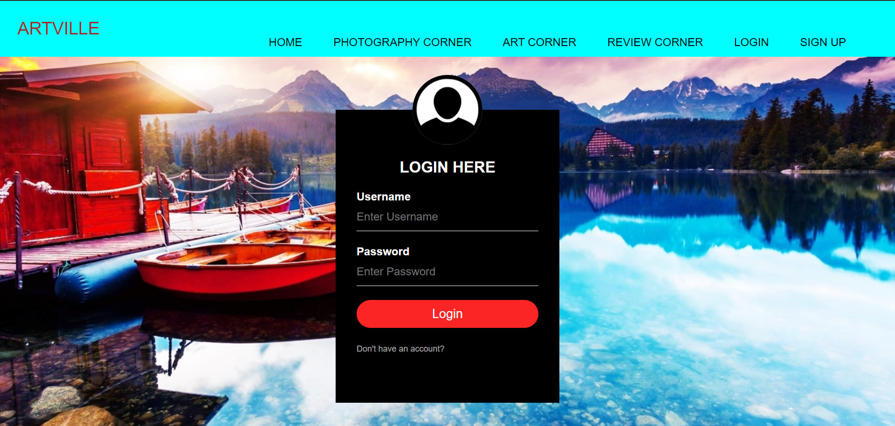

SIGN UP PAGE:

